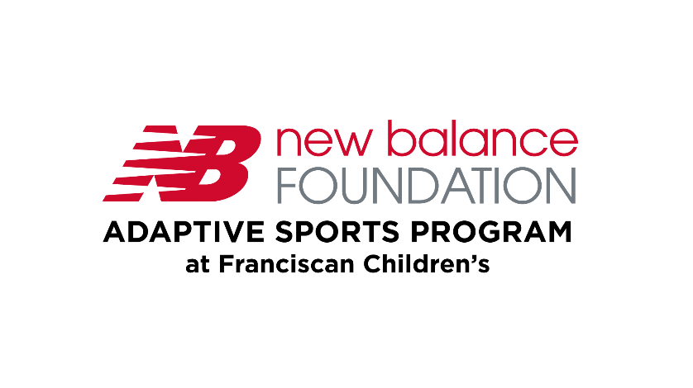

Participant Registration Form
Session: Choose an item. Session Time: Choose an item.
Tell us about your child.
Name:
Age:
Gender: | Choose an item.
Pronouns: | Choose an item.
Race: Choose an item. |  | Ethnicity: Choose an item.

Tell us about Parent/Guardian/Caregiver
1st Parent/Guardian/Caregiver |  | 2nd Parent/Guardian/Caregiver
Name: |  | Name:
Address: |  | Address:
Phone Number: |  | Phone Number:
Email: |  | Email:

Who can we call for in case of an emergency?
Name:
Address:
Phone Number:
Email:

Tell us about important care directions for your child:
Disability- tell us details that can be helpful for us in making sure your child has fun and is safe (i.e., vision, hearing, seizures, etc.):
Does your child have difficulty communicating? Choose an item.
If so, please describe the best way(s) to communicate: | Do they use an AAC Device? Choose an item.
 | What kind
 | Software
 | Number of symbols per page:
Does your Child have any problems with vision or hearing | Choose an item.
If so, please describe how to best accommodate?
Will your child need a snack or g-tube feed? | Choose an item.
If yes, please provide directions and a feeding schedule:
Will the Nurse or staff need to assist with toileting | Choose an item.
If Yes, please provide toileting schedule while at camp:
Does your child have a behavioral plan or IEP? |  | Choose an item.
If yes, attach plan to application if comfortable
Does your child require one-to-one?: Choose an item.
We are happy to help with this question - send us an email paward@franciscanchildrens.org

Tell Us about Medications that may be needed during camp hours:
Will your child require a nurse provide medication during camp hours? |  | Choose an item.
Time | Medication Name |  | Dosage

These are needed to complete registration:
☐ | Liability Waiver
☐ | Photo Waiver
☐ | Would your family like to apply for financial aid?  Yes  No
☐ | Would your family like to donate for another participants session?  ☐Quarter Session  ☐Half Session  ☐Full Session
These are needed to complete registration: Liability Statement, Photo Release
Liability Statement:
I, as Guardian of the child named in this form, have requested that my child participate in the Choose an item. at New Balance Foundation Adaptive Sports Program at Franciscan Children's by Franciscan Hospital for Children, Inc., d/b/a Franciscan Children’s. I understand that there are inherent risks in such programs, including risk of injury to my child, and that other unknown hazards may arise during the course of this program that are not reasonably foreseeable to Franciscan Children's.
I, as Guardian of the child named in this form, assume all risk of injury to my child that may occur as a result of or in connection with Choose an item. run by New Balance Foundation Adaptive Sports Program at Franciscan Children's. I, on behalf of myself, my child and his/her assigns, heirs, executors, and administrators, hereby hold harmless and unconditionally and irrevocably remises, releases and forever discharge Franciscan Children's and its past, present and future officers, directors and employees of and from any and all suits, claims, demands, interest, costs (including attorney fees and costs actually incurred), expenses, actions and causes of action, rights, liabilities, obligations, promises, agreements, controversies, losses and debts arising from or in connection with the Adaptive Sports Programs described above.
Sign |  | Date

